Ask mode: Prompt: Context: You are an software architect.
Instruction: 1. Read the entire framework and add Playwright + Javascript combination as like Playwright + Typescript already exists.
2. Let me know the which are files are impacted and changes in files.
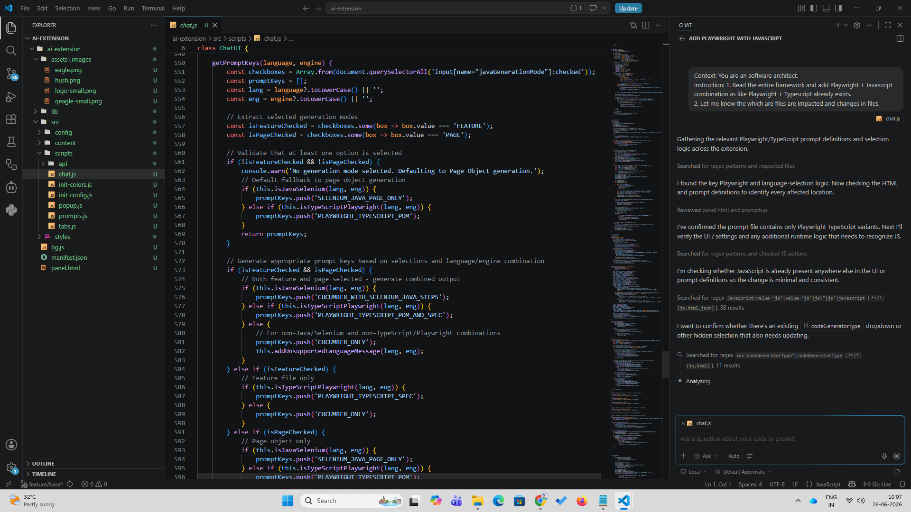
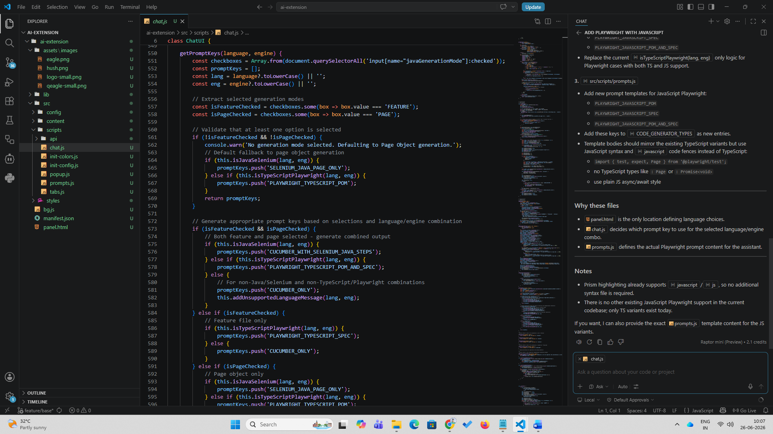

Agent mode: Implement the above plan step by step after my approval
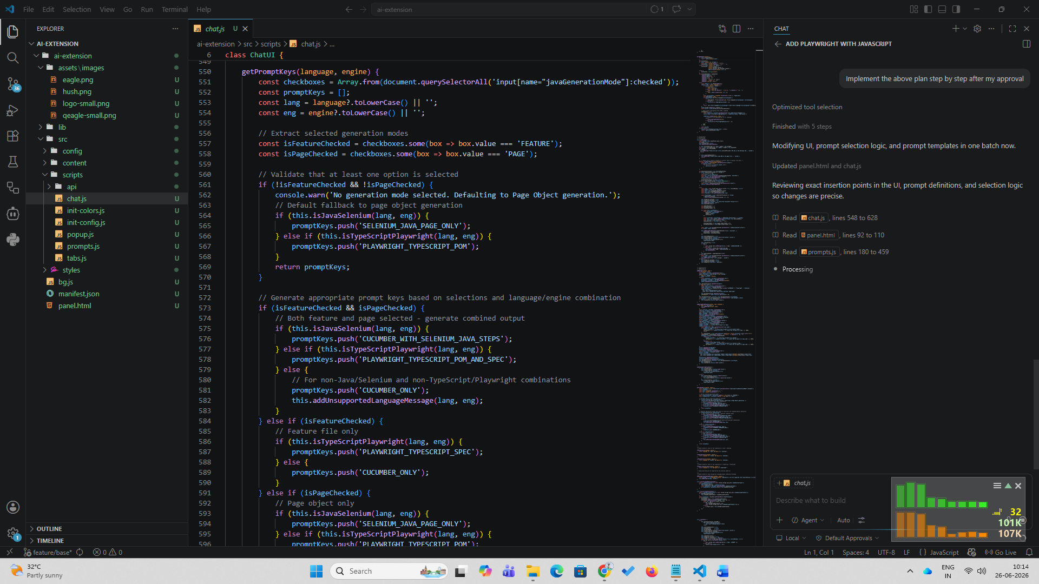
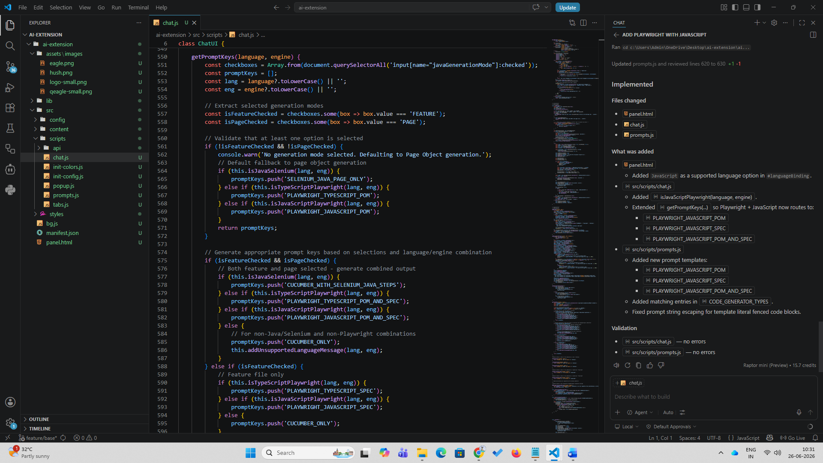
Playwright with Javascript Added
